NOMINATION FORM

Complete the nomination form below and return with a 1-2 page justification that specifies the nominee’s accomplishments and any direct impact on farmland preservation in Connecticut.

Select only one award category below:

* Outstanding Individual Award

For outstanding achievement by an individual in advancing farmland preservation in the State of Connecticut.

* Outstanding Group Award

For outstanding achievement by a group (public, private, or non-profit) in advancing farmland preservation in the State of Connecticut.

* E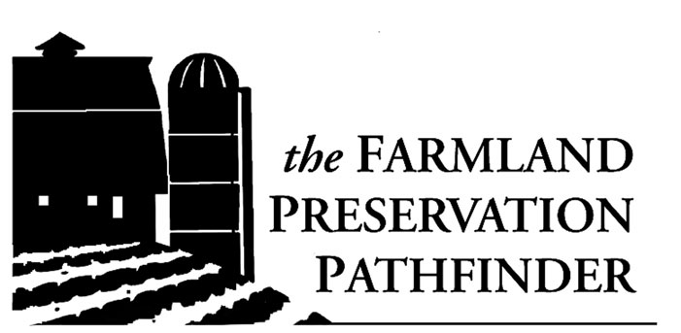ducation Leader Award

For significant contributions in the area of educating the public about the importance of farmland preservation (individual or group is eligible).

|  |  |
| --- | --- |
|  | NOMINEE: |
| NAME |  |
| TITLE |  |
| ADDRESS |  |
| TELEPHONE |  |
| E-MAIL |  |

Submitted by:

Name: \_\_\_\_\_\_\_\_\_\_\_\_\_\_\_\_\_\_\_\_\_\_\_\_\_\_\_\_\_\_\_\_\_\_\_\_\_\_\_\_\_\_\_\_\_\_\_\_\_\_\_\_\_\_\_\_\_\_\_\_\_

Title/Organization \_\_\_\_\_\_\_\_\_\_\_\_\_\_\_\_\_\_\_\_\_\_\_\_\_\_\_\_\_\_\_\_\_\_\_\_\_\_\_\_\_\_\_\_\_\_\_\_\_\_\_\_

Daytime Telephone \_\_\_\_\_\_\_\_\_\_\_\_\_\_\_\_\_ Email: \_\_\_\_\_\_\_\_\_\_\_\_\_\_\_\_\_\_\_\_\_\_\_\_\_\_\_\_

\*\*\*PLEASE DO NOT SUBMIT A NOMINATION WITHOUT A 1-2 PAGE JUSTIFICATION

EXPLAINING THE NOMINEE’S ACCOMPLISHMENTS

RETURN BY October 8, 2019.

Mail to Chelsea Gazillo – Working Lands Alliance, 78 Beaver Rd. Suite 2A Wethersfield, CT 06109

Email to cgazillo@farmland.org

WLA_logo_final_2013

Established in 2003 by Working Lands Alliance, a broad-based statewide coalition of individuals, organizations and businesses dedicated to preserving Connecticut’s productive farmland, **Farmland Preservation Pathfinder Awards** are designed to recognize individuals and groups that have significantly advanced farmland preservation through leadership, advocacy, planning, and education.

***PAST WINNERS***

|  |  |
| --- | --- |
| **2017**   * **Weantinoge Heritage Land Trust** * **Jennifer Kaufman, AICP** * **Mountain Dairy** | **2018**   * Roxbury Land Trust * Matthew Peckham |
| **2016**   * Walter Adametz, Middlesex County Farm Bureau President * Town of Bethany | **2009**   * Eastern CT Resource Conservation &   Development Area, Inc.   * Gordon Gibson, CT State Grange |
| **2015**   * Ben Freund, Freund’s Farm * The Last Green Valley * Joan Nichols | **2008**   * Linda Francois, Cooper, Whitney, Cochran & Francois * New Milford Farmland Preservation Comm. * Jonathan Rapp & Drew McLachlan, Dinners at the Farm |
| **2014**   * George Hindinger, Hindinger Farm * Wintonbury Land Trust * UCONN Extension Agriculture Team | **2007**   * Dawn Adiletta, Chair of Woodstock Open Space Land Acquisition and Farmland Preservation Committee * Town of Lebanon * Connecticut Tour des Farms Committee |
| **2013**   * Tom Crider, Southbury Land Trust * The Farmer’s Cow * George Hall, George Hall Farm | **2006**   * William Paradis, Paradis Farm, Ashford * Town of Guilford Agriculture Steering Committee & Guilford Land Acquisition Commission * Green Valley Institute |
| **2012**   * Ellington Conservation Commission * Connecticut Farm Bureau Association * Llyn Kaimowitz, Working Lands Alliance   Steering Committee Member   * Nicholas Moore, Connecticut Farmland Trust | **2005**   * John Turenne, Sustainable Food Systems, Inc. * Simsbury Land Trust * CT Natural Resource Conservation Service |
| **2011**   * Ray Wilcox, Chairman of Suffield’s Open Space Committee * Andrew Rzeznikiewicz, a Pomfret Resident   and Sanctuary Manager for the Connecticut Audubon Center at Pomfret   * The Agvocate Program | 2004   * Mayor Mark Lauretti, Shelton * Southbury Land Trust * Woodstock Coordinating Committee for Celebrating Agriculture Fair |
| **2010**   * Faith Middleton, WNPR host of the Faith Middleton Show * Town of Pomfret * Woodbridge Conservation Comm. and Board of Directors of Massaro Community Farm | 2003   * Robin Chesmer, Graywall Farms * Terry Jones, Jones Family Farm * Phil Chester & Town of Suffield * Connecticut Envirothon |