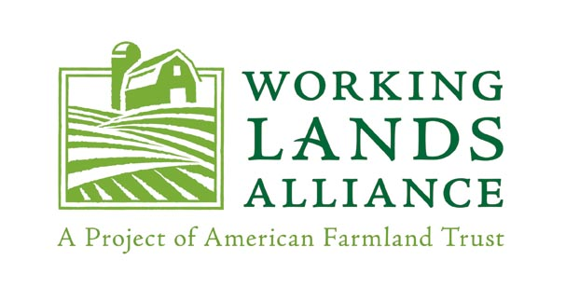

Environment Committee

Connecticut General Assembly
Legislative Office Building, Room 3200
Hartford, CT 06106

April 11, 2018

Dear Senator Kennedy, Senator Miner, Representative Demicco, Ranking Member Stephen Harding and members of the Environment Committee:

Since 1999, Working Lands Alliance (WLA), a broad-based, statewide coalition dedicated to preserving Connecticut’s farmland, has been the leading advocate for the CT Department of Agriculture’s Farmland Preservation Program. For the past forty years, the program has protected 353 farms and 45,078 acres of farmland in the state.

To further leverage the Department of Agriculture's capacity to efficiently process PDR applications, WLA supports the inclusion of this technical correction to it authority, either in SB 102 or a similar piece of legislation. This correction would enable the Department to undertake "buy-protect-sell" projects in collaboration with land conservation partners, ensuring that the Department can move quickly to purchase farmland, and then work with land trusts to protect the property and sell the protected land to an established or new farmer. For farmers and farmland owners who need or want to sell their land rather than just an easement, this "buy-protect-sell" option offers a valuable way for them to extract the equity from their land but still see their land protected and sold to a farmer. WLA understands that the Department has identified the first such project for which it hopes to use this authority, so timely action on this change would allow the Department to move forward with this and future projects.

On behalf of the Working Lands Alliance, I urge the Committee to move forward with this valuable statutory change. Please know that we are available to act as a resource should you seek additional information on this language, or other legislation affecting farming and farmland.

Sincerely,
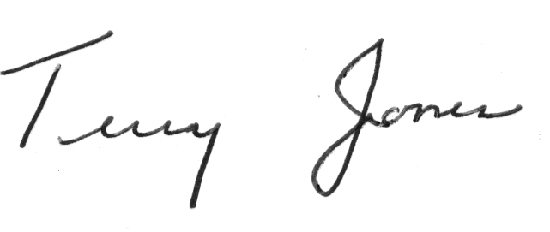
Terry Jones
Working Lands Alliance Chair

